Jesse Mendes
Period 6
11/18/11
My Survey Results
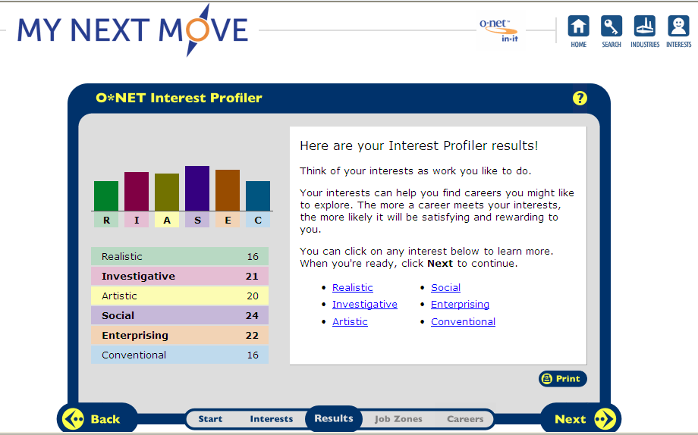
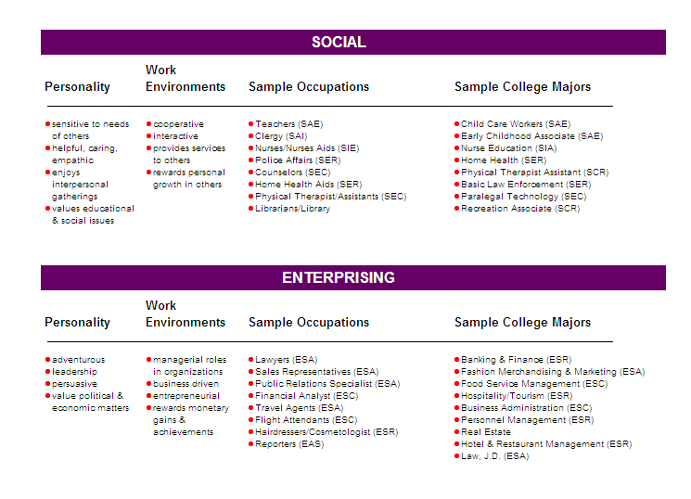
Social
I believe that I am a social person because I always want to help people. I don’t know if it’s just how I am or if I just act that way for the happiness of others. Also, I believe that I help people out people because I can’t bear to sit there and watch them struggle. Whenever people have issues, I work to resolve them. When somebody is hurt or upset, I always volunteer to help them get through their tough situation. I’m so invested in helping people that I can’t understand why I can’t resolve my own problems.

Career Choices
- School Teacher
- Police Officer
- Athletic Trainer
- Coach
Enterprising

I agree with the findings from the enterprising topic in this survey. I think I am an adventurous person because I enjoy attempting new activities. I would say I am a leader because I always try to show my way of doing things to other people. One of my most used phrases when talking about work or activities is, “I would do this that way” or something like that. I always want my voice to be heard, but I want to stay as humble as possible while doing so.

Career Choices
- Legislator
- Gaming Supervisor (casino manager)
- Lawyer
- Flight Attendant

Career Questions
Human Resources Manager (HRM):
1. What is the definition of each occupation that you have chosen and the nature of the work?
2. What are some of the related occupational fields?
3. Which personality type(s) is best suited to the occupations/jobs you have researched?
4. What kind of education, training and qualifications are required?
5. What technology skills are needed to be successful in the career/occupational fields you have explored?
Recruiting Consultant (RC):
6. What does each occupation pay, or what are the average earnings nationally and in this area of the country?
7. What is the projected growth for this career field over the next 10 years? (i.e. will there be more or less jobs like this in the future?)
8. Please identify local or national organizations that would hire someone in each career field you have explored.
Interview Services Consultant (ISC):
9. What are the working conditions or work environment for each job you or your group decided to research (such as work schedule, hours, exempt/salaried or non-exempt/hourly, etc.)?
10. Are positions in this career field typically part of collective bargaining units (unions)?
11. What kind of opportunities for advancement are there for each career? (i.e. Is there a chance to get promoted, etc.?)
Career Choices
Coach
- A coach is responsible for teaching an athlete the basics of a game and refines their abilities. Coaches help athletes train their bodies, practice their skills, and engage their talents the correct way.
- Some related occupational fields are being a scout, a trainer, or an athlete that plays for a coach.
- A person with an open mind who is social and unafraid for his voice to be heard is the right personality for a coach.
- The amount and quality of your education depends on the sport you coach and what level of the sport you are at.
- A coach only needs to be able to use a phone to contact people and players, and a computer to be able to email and communicate with coaches and athletes.
- There starting wage is around $40,000 at the collegiate or professional level.
- The amount of coaches is expected to grow 23 percent between 2008 and 2018 because of the amount of sports and activities.
- A sports team at the high school, recreational, professional, or collegiate level would try to hire a coach.
- A coach works irregular hours, and you make a yearly wage not hourly wage.
- Yes, coaches take part of a collective bargaining unit.
- You can be promoted from a coach that focuses on certain players to an assistant coach, then to a head coach or manager.

Police Officer
- Police officers enforce laws made for citizens to follow.
- Related occupational fields include detective, investigator, and a CSI.
- A police officer would have to be a social parson who is a leader.
- Most police officers must be U.S. citizens. They must be healthy, strong, and of good character. To get a job, a person must pass a written test, be at least a high school graduate, and have some work experience.
- Police officers need to be good with radios, laptops, and technology to relay information to and from other police officers.
- Police officers had average yearly wages of $52,810. There start wages are around $30,000.
- Employment of police officers and detectives is expected to increase at a rate of 10.1 percent.
- A police officer would be hired by a sheriff, a lieutenant, or captain of the police force.
- Some police officers work outdoors in all kinds of weather. Some take very big risks when they chase criminals in cars or when they make an arrest. Good training, teamwork, and good equipment keep police officers safe.
- Police offers are a part of a union.
- Police officers can get their rank promoted to lieutenant, captain, or chief of a force.
Gaming Manager (Casino Manager)
- Casino Managers overlook gambling at a casino to make sure people aren’t being a nuisance or cheating on the floor.
- Related occupational fields include being a poker/blackjack dealer, or being a security personnel worker on a casino floor.
- A gaming manager needs to be an adventurous person who can be a leader.
- Some of the major casinos and slot machine manufacturers run their own training schools, and almost all provide some form of in-house training in addition to requiring certification. The type and quantity of classes needed may vary. Many institutions of higher learning offer training or classes toward certificates in gaming, as well as offering associate’s, bachelor's, or master's degrees in a variety of hospitality-related fields, such as hospitality management, hospitality administration, or hotel management. Some schools offer training in games, gaming supervision, slot attendant and slot repair technician work, slot department management, and surveillance and security.
- A casino manager needs to be able to work with and around loud machinery such as slot machines and money counters.
- Gaming manager make $68,290 per year.
- Between 2008 and 2018, this job is projected to grow 14%.
- A casino manager can be hired by a casino or a hotel with a casino in it.
- Gaming managers work in casinos and gambling centers.
- Gaming managers are not part of a union.
- Gaming Managers are the highest worker on the chain of casino supervisors, dealers, and bookkeepers.

Lawyer

- Lawyers give people and companies advice and tell them what they can and can't do under the law.
- Related occupational fields are judges and politicians.
- A lawyer needs to be a strong leader who makes good decisions.
- In May 2008, the average yearly wages for lawyers were $124,750.
- Lawyers need to be able to be contacted by email or cell phone.
- In May 2008, the average yearly wages for lawyers were $124,750. Lawyers starting salary is usually around
- Lawyers are supposed to grow at a rate of 13% from 2008 to 2018.
- A lawyer could be hired by a criminal, a law office, or a court.

Career Data Charts:

- I narrowed my possible careers to being a coach, police officer, or a lawyer. I chose a coach as a possibility because they have a decent amount of education, and there is a high job growth percentage. I also picked police officer because they have a low amount of schooling, but make a high average salary, and have a decent growth. Lastly, I chose a lawyer because they get the most education, and they have a high average salary.

- Coach
- Drexel University
- University of Memphis
- University of Louisville
Police officer
- Bristol Community College
- Virginia Commonwealth University
- Purdue University
Lawyer
- Boston University
- University of Missouri: Columbia
- University of Oklahoma

